Alpbach Team Europe
European Forum Alpbach
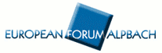
GRANT CALL
European Forum Alpbach 2009

“Trust”

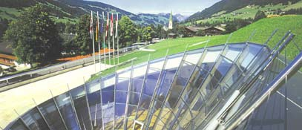
20 August – 5 September 2009
Alpbach / Tyrol / Austria
www.alpbach.org
Target group
The grant is designed for Students, young graduates and young workers from EU Member States and associated Countries focusing on European policy-making, European issues and who are active in EU-related debates and reflection groups. (E.g. trainees and young employees working in European institutions, Permanent Representations, offices of the regions/Länder as well as in offices/ companies based in Brussels and active in a close European context).
NOTE: Young people from Austria should address their applications to one of the corresponding initiatives in Austria
(see www.alpbach.org)

Coverage
The grants are sponsored by the private sector and notable personalities and institutions. The grants cover entirely the participation fees (€ 500) of the European Forum Alpbach for all 16 days and accommodation expenses. Travel arrangements will however remain at the charge of the participant.

Award
Applicants will be informed of the result of their application during the second half of June 2008. The award of the ALPBACH - EUROPE GRANTS will be certified by the Austrian Permanent Representative to the EU.

Eligibility criteria

- Curriculum Vitae (max. 2 pages)
- Letter of motivation (max. 6000 letters)
- Letter of recommendation (at least one but preferably two – in French, English or German)
- Confirmation of study performance (e.g.: by graduation certificates)

NOTE: please enclose to the application also your contact address (post address/ (mobile) telephone number/ e-mail address) so that we can contact you – if necessary – before and during the summer holidays!
Please send your application to the following address:
Alpbach Team Europe / Grant Campaign
Vertretung der Europaregion Tirol-Südtirol-Trentino bei der EU
Rue de Pascale 45, 1040 Bruxelles

Deadline for applications: Tuesday 2 June 2009
Applications will be accepted after the final date only if postal stamp is of the final date or earlier

For further information please contact:
Alpbach Team Europe
Europe Grants: alpbach_teameurope@yahoo.com

BACKGROUND INFORMATION

On the European Forum Alpbach

The European Forum Alpbach 2009 is devoted to the general theme “Trust”. It will take place in the second half of August and traditionally is a meeting place for leading representatives from science, economy, politics, culture and media.
Since it was founded in 1945, the European Forum has taken place annually in the picturesque village of Alpbach in the Tyrolean mountains, which provides an impressive frame for an open and interdisciplinary discourse. Shortly after WW II, the idea of an intellectual exchange with participants coming from different European countries was quite revolutionary. Today, the European idea is higher on the Agenda than ever. The support of European unification shall again be at the core of Alpbach´s Congress activities.
For more than fifty years, the Forum has attracted high representatives from politics, economy, science, culture and media from all over Europe and beyond with its programme and its specific offer of a unique informal, supranational platform. Right from the beginning students and young graduates have been invited to participate in the forum and to join discussions as well as to contribute to the debate.
By awarding «Alpbach Europe Grants», the Alpbach Team Europe intends to support an increasing participation of students, young graduates and young workers, in order to
- - strengthen the contacts between “Europe” and the Forum Alpbach
- - support the European discourse in the frame of the Forum Alpbach
- - contribute to a further internationalisation of (young) participants as well as of the Forum itself.
The European Forum Alpbach is currently presided by Erhard Busek, former Vice Chancellor of Austria and Special Co-ordinator of the Stability Pact for South Eastern Europe.
This year, the Forum focuses again on discussions in the fields of science, politics, economy and culture. The first week has a strong scientific approach: seminars and plenary sessions alternate.
The second week with its Technology Forum, Health Symposium, Media Symposium and Political Events is more oriented towards current professional priorities and is usually well echoed in the media, politics and the business community.

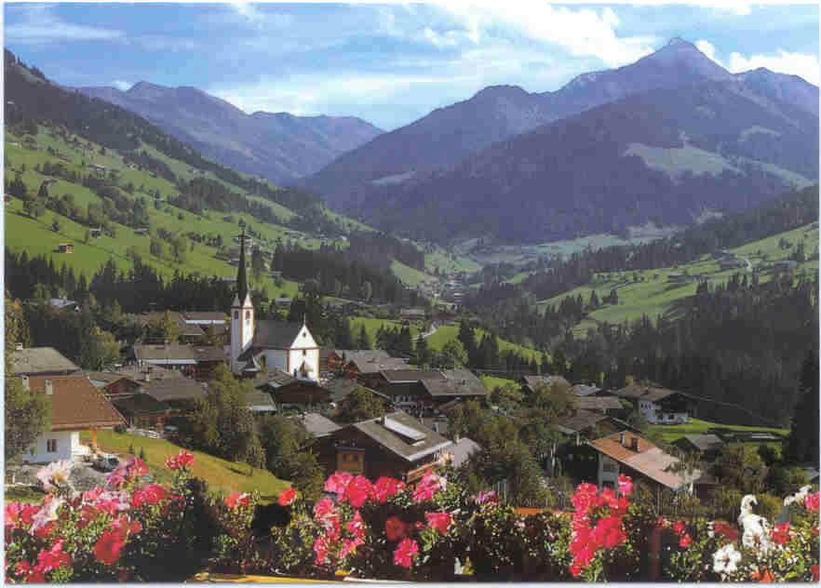
The Village of the Thinkers

Languages used are primarily German and English. Although a basic command of German is helpful, it is not indispensable. All the conferences offers interpretation services and half seminars are held in English. The strong European character of the Forum generates a multilingual debating platform. Interested groups often organise meetings/Kamingespräche in their chosen language, French for instance.
Please see this year’s program.

